NORTHWIND INTERACTIVE SALES DASHBOARD

MONISRI L
E25FA028
B.COM FINTECH AND AI 2nd YEAR

1. Introduction
In this project, I developed an interactive Sales Dashboard using Microsoft Power BI with the Northwind dataset. The purpose of this project is to study business sales information and understand the performance of orders, products, customers and employees.
First, I imported the Northwind dataset into Power BI. I prepared the data using Power Query and created measures using DAX. Then, I designed different charts, tables and KPI cards to display the results clearly.
The dashboard helps to understand monthly orders, product category sales, employee performance and customer details. I also used slicers, tooltips and drill-through features to make the report more useful and interactive.
2. Objectives
The main objectives of this project are:
- To understand the overall sales performance.
- To analyse the number of orders received.
- To compare sales between different product categories.
- To study employee-wise order performance.
- To analyse customers from different countries.
- To understand monthly order changes.
- To identify the sales and quantity of individual products.
- To prepare and organise data using Power Query.
- To create useful DAX measures.
- To develop an interactive dashboard using Power BI.
- To use slicers and tooltips for better analysis.
- To provide detailed information through drill-through.
3. Data Preparation Using Power Query
After importing the Northwind dataset, I used Power Query Editor to prepare the data for analysis.
The main purpose of this step was to make the data suitable for creating charts and reports.
The data preparation process includes:
- Checking the available tables and columns.
- Reviewing the data before creating visuals.
- Making sure the required fields are available.
- Preparing the data for further analysis.
- Loading the prepared data into Power BI.
Power Query helped me organise the dataset before creating the dashboard.
4. DAX Measures Used
I used DAX measures to calculate important business values from the Northwind dataset.
Measure | Purpose
Total Orders | Displays the total number of orders.
Total Sales | Calculates the overall sales amount.
Total Freight | Shows the total freight charges.
Total Quantity Sold | Displays the total quantity of products sold.
Average Freight | Calculates the average freight amount.
Number of Customers | Shows the total number of customers.
|
These measures help to display important information in KPI cards, charts and tables.
5. KPI Cards
I used KPI cards to show the important business details in a simple way.
The main KPI measures include:
- Total Orders
- Total Freight
- Total Quantity Sold
- Average Freight
- Number of Customers
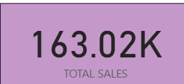 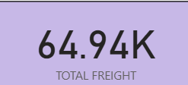 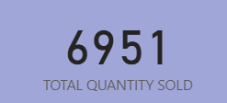 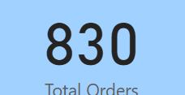
KPI cards help users understand the overall business performance quickly without checking every chart.
6. Visualisations Used
6.1 Orders by Month
I used a Line Chart to display the number of orders received in each month.
- X-axis: Month
- Y-axis: Total Orders
This chart helps to understand how orders change throughout the year. It also helps identify months with more and fewer orders.
Data Labels: Display the order values on the chart.
Tooltip: Shows the month and the corresponding number of orders.
6.2 Sales by Product Category
I created a Column Chart to compare sales across different product categories.
- X-axis: Category Name
- Y-axis: Total Sales
This chart helps to identify which product categories generate more sales and which categories generate less sales.
Data Labels: Show the sales amount for each category.
Tooltip: Displays the category name and total sales.
6.3 Orders by Employee
I used a Bar Chart to compare the orders handled by different employees.
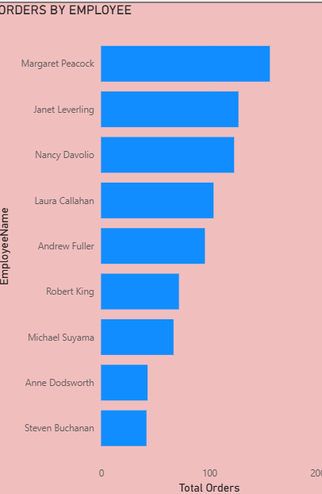
- Y-axis: Employee Name
- X-axis: Total Orders
This chart helps to understand employee-wise order performance and compare the number of orders handled by each employee.
Data Labels: Display the total orders for each employee.
Tooltip: Shows the employee name and total orders.
6.4 Customers by Country
I used a visual to study the number of customers in different countries.
- Category: Country
- Value: Number of Customers
This visual helps to understand the location of customers and identify countries with more customers.
Data Labels: Display the customer count.
Tooltip: Shows the country name and number of customers.
6.5 Product-wise Analysis
I created a table to show detailed information about individual products.
The table includes:
- Product Name
- Category Name
- Total Sales
- Total Quantity Sold
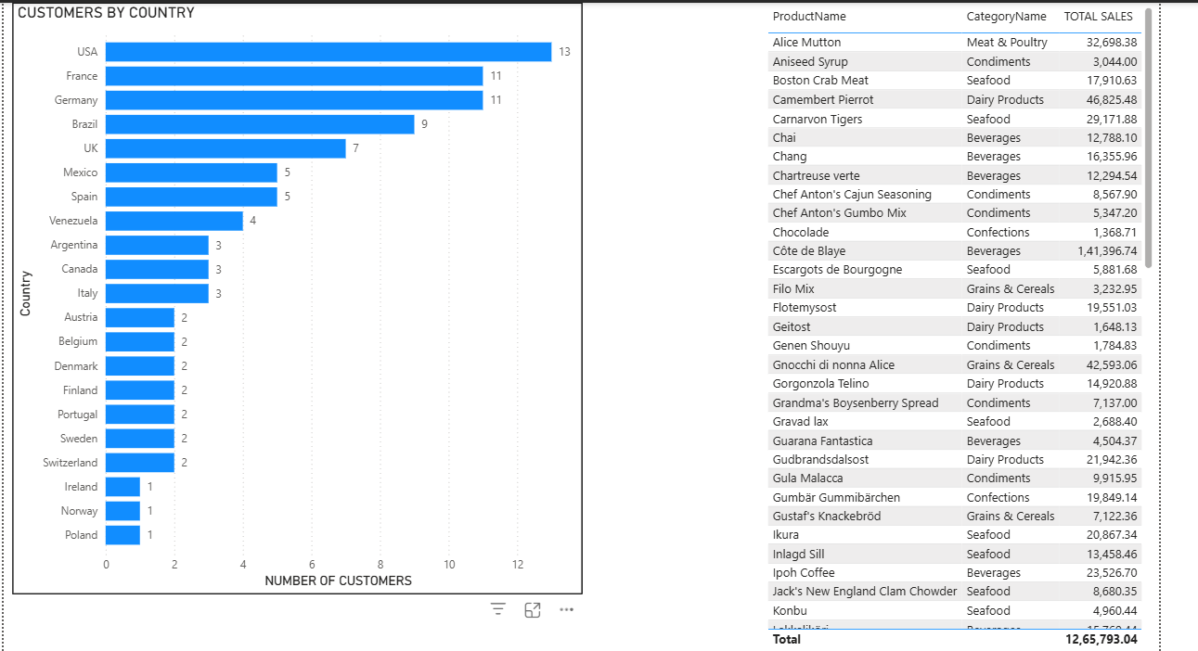
This table helps to compare different products based on their sales and quantity.

7. Data Organisation and Category Analysis
I organised the Northwind data to make the category and product analysis easier.
Product categories are used in charts, tables and filters to compare sales performance.
This helps users understand the contribution of each category and study product-level information clearly.
8. Tooltips
I used tooltips to show additional details when the user moves the mouse over a chart or visual.
The tooltip information includes:
Visual | Tooltip Details
Orders by Month | Month and Total Orders
Sales by Category | Category Name and Total Sales
Orders by Employee | Employee Name and Total Orders
Customers by Country | Country and Number of Customers
Product Analysis | Product Name, Sales and Quantity
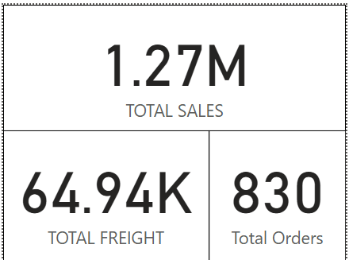
Tooltips provide extra details without displaying too much information on the main dashboard.
9. Data Labels
I used data labels in the charts to display the exact values directly on the visuals.
They help users understand the results more easily.
Examples include:
- Monthly total orders.
- Sales of each product category.
- Orders handled by employees.
- Number of customers in different countries.
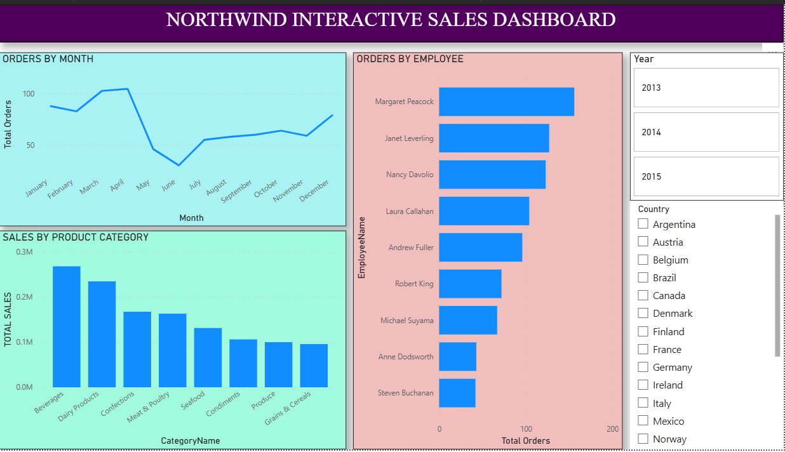
Data labels make the charts easier to read and understand.
10. Slicers and Interactivity
I added slicers to make the dashboard interactive.
The main slicers used are:
- Year
- Country
- Category
When a user selects a particular year, country or category, the related charts and information change according to the selection.
This feature helps users analyse the data based on their requirements.
11. Drill-through Analysis
I used the Drill-through feature to provide more information about a selected category.
When a user selects a category from the main dashboard and chooses the Drill-through option, Power BI opens a separate Category Details page.
This page provides additional information about the selected category.
Benefits of Drill-through:
- Provides detailed information about selected data.
- Helps users study individual categories.
- Keeps the main dashboard simple and clear.
- Makes the report more interactive.
- Helps users move between summary and detailed information.
I also added a Back button to return to the main dashboard after viewing the details.
12. Dashboard Pages
My Northwind Power BI project contains five pages.
1. Sales Overview
Displays the main sales and order information for understanding overall performance.
2. Product & Customer Analysis
Shows product details, sales information and customer-related analysis.
3. Interactive Sales Dashboard
Contains charts, slicers and other visuals to analyse sales and orders interactively.
4. Category Tooltip
Provides additional information about product categories when viewing the related visuals.
5. Drill Through
Displays detailed category information based on the selected category from the main dashboard.
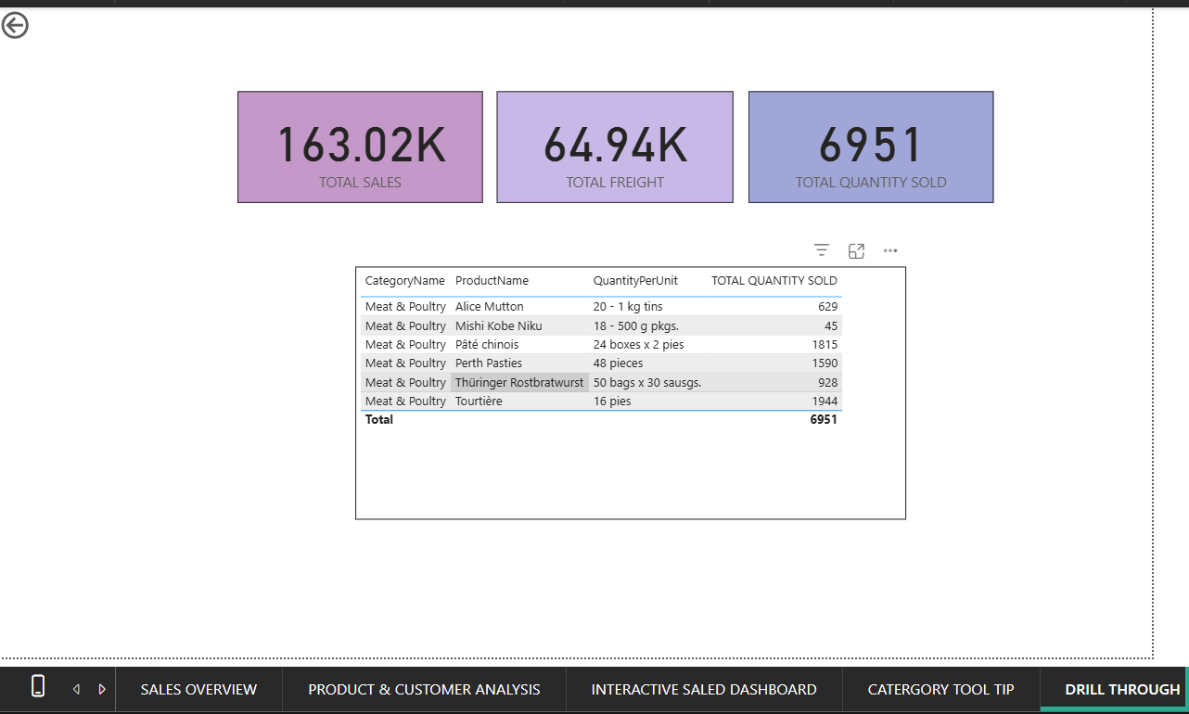
13. Key Findings
Through this dashboard, I was able to understand different areas of business performance.
The important findings include:
- Monthly order performance can be understood using the line chart.
- Sales can be compared across different product categories.
- Employee performance can be studied through order details.
- Customer distribution can be analysed country-wise.
- Individual product sales and quantities can be compared.
- Total freight and average freight can be understood using DAX measures.
- Year-wise information can be analysed using the Year slicer.
- Country-based information can be filtered using the Country slicer.
- Category-wise performance can be studied using the Category slicer.
- Additional details can be viewed using tooltips.
- Drill-through helps to analyse selected categories in detail.
- Power BI makes business information easier to understand through visualisation.
14. Conclusion
Through this Northwind Sales Dashboard project, I learned how to create an interactive business report using Microsoft Power BI. I used Power Query to prepare the data and DAX measures to calculate important business information.
I created different charts, tables and KPI cards to analyse sales, orders, products, employees and customers. I also used slicers, data labels, tooltips and drill-through to make the dashboard more useful and easy to understand.
Overall, this project improved my knowledge of Power BI and helped me understand how data can be converted into meaningful information for business analysis and decision-making.

